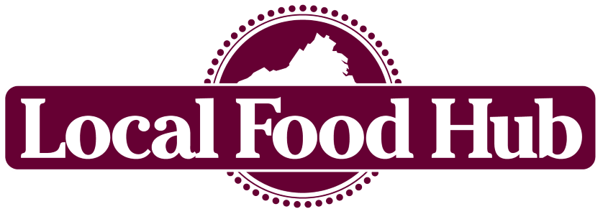

Membership Agreement

Local Food Hub, Inc. (LFH) is a nonprofit organization that partners with Virginia farmers to increase community access to local food.

By joining Local Food Hub, Partner Producers have access to valuable services and support in accessing markets. You are expected to adhere to specified procedures and guidelines,. In turn, farms are expected to adhere to specified food safety procedures and transparent farming practices, and actively partner with LFH.

Member Information:

Producer Name | Primary Contact Person
Mailing Address
City, State, | Payee (to appear on check if needed)
Zip
Phone | Email
Physical Address (if different from | County
above)

This membership agreement (the “Agreement”) will serve as a mutual understanding of terms and conditions between Local Food Hub, Inc. (“LFH”) and the producer (the “Producer”) listed above.

(over)

The Producer agrees to the following (please initial each line):

- The Producer agrees to comply with procedural guidelines as outlined in the Local Food Hub Producer Manual. Furthermore, LFH reserves the right to make changes, with sufficient notice, to its procedural guidelines.

- The Producer provides permission to LFH to use general information and photographs taken on the Farm in order to publicize the partnership.

This Agreement is valid from the effective date below, until terminated in writing by either party.

By signing below, the member hereby agrees to be bound by the terms and conditions contained in this Agreement.

(print name) (signature) (effective date)

(over)

